**eMERGE Network Proposal for Analysis**

Project/Manuscript Concept Sheet

|  |  |
| --- | --- |
| **Reference Number** | NT256 |
| **Submission Date** | September 7th, 2017 |
| **Project Title** | Revealing hidden white blood cell count phenotypes for gene discovery: deep phenotyping with latent class mixed modeling. |
| **Tentative Lead Investigator (first author)** | Taryn O. Hall |
| **Tentative Senior Author (last author)** | David R. Crosslin |
| All other authors | Gail P. Jarvik, Ian B. Stanaway |
| **Sites Involved** | All eMERGE sites |
| **Background / Significance** | White blood cell (WBC) count is a marker of systemic inflammation and immune system health. WBC count varies acutely in response to infection and other environmental exposures, however resting-state WBC may be an indicator of chronic disease risk. Elevated resting WBC count has been associated with metabolic syndrome[(Chao et al. 2014; Pei et al. 2015)](https://paperpile.com/c/JHNnCi/h5kVP+ciwsU), cardiovascular disease[(Huh et al. 2015; Loimaala et al. 2006)](https://paperpile.com/c/JHNnCi/TVGDI+T07yB) and mortality[(Nilsson, Hedberg, and Ohrvik 2014; Ahmadi-Abhari, Luben, and Wareham 2013)](https://paperpile.com/c/JHNnCi/m2r2X+hmZ5a)). This may reflect excess inflammation as evidenced by WBC count, or leukocytes may contribute directly to disease [(Coller 2005)](https://paperpile.com/c/JHNnCi/XFaw2).  There is evidence that steady-state WBC count is not fixed over time. Longitudinal analysis has shown a U-shaped pattern in WBC counts over the lifespan, with the point of inflection around 60 years old [(Chmielewski et al. 2016)](https://paperpile.com/c/JHNnCi/wxFL). Heterogeneity in WBC count trajectory also exists and some trajectories are associated with morbidity and mortality[(Ruggiero et al. 2007)](https://paperpile.com/c/JHNnCi/gQMs). Because WBC count is also influenced by adiposity, changes in steady-state WBC count may reflect age-related change in body composition. However, in a mouse model, different strains exhibited different WBC count trajectories, indicating these trajectories may be under genetic control [(Telieps et al. 2016)](https://paperpile.com/c/JHNnCi/Y0wuI).  Deep phenotyping aims to increase the granularity of a phenotype in hopes that a more precise phenotype will increase the power of a GWAS and lead to more precise and larger effect size estimates[(Manchia et al. 2013)](https://paperpile.com/c/JHNnCi/ut3Rj). Extending a phenotype over time by characterising different patterns in longitudinal data is one strategy to deepen phenotype[(Tracy 2008)](https://paperpile.com/c/JHNnCi/10ciX). Trajectory heterogeneity may be difficult to observe in large, observational datasets using standard statistical methods. Latent class mixed modeling (LCMM) is a method that can identify unobserved heterogeneity in longitudinal data and attempts to classify individuals into groups based on a linear model of repeated measurements over time [(Proust-Lima, Philipps, and Liquet 2017)](https://paperpile.com/c/JHNnCi/v6Nr). |
| **Outline of Project** | 1. Run LCMM on WBC counts repeated measures to identify latent, trajectory-based phenotypes (already completed)  2. Move latent phenotype forward to GWAS with imputed data for gene discovery (already completed)  3. Draft manuscript (in the process)  4. Publish |
| **Desired**  **Variables (essential for analysis**  **indicated by *)** | **Phenotypes:**   1. Repeated measures of WBC counts* and differential already collected in eMERGE I and stored at UW.   **Covariates:**  Demographic: Height, weight (at visit), sex, self-identified race and age at event*. |
| **Desired data** |  |
| **Planned Statistical Analyses** | 1. Run LCMM to discover latent trajectory based phenotype  2. GWAS with identified latent phenotypes as a logistic regression analyses. |
| **Ethical considerations** | There are no physical risks involved. |
| **Target Journal** | Genes and Immunity |
| **Milestones\*\*** | Construct latent phenotype using LCMM  GWAS with latent phenotype and imputed data  Draft manuscript  Publish |

**\*\*** This section should include: Timeline for completion of project, including approval, project duration, first and second draft of the paper and submission.

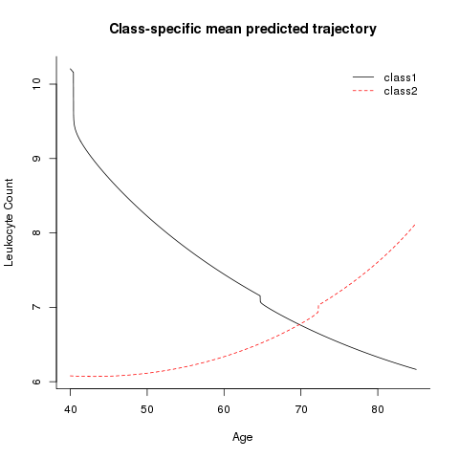

Image 1: Latent trajectory phenotypes revealed by LCMM 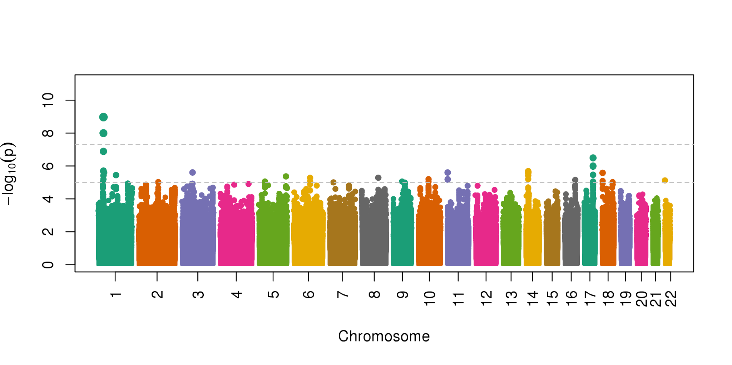

Image 2: GWAS (all ancestry) of latent phenotypes using imputed genetic dataset

References

[Ahmadi-Abhari, S., R. N. Luben, and N. J. Wareham. 2013. “Seventeen Year Risk of All-Cause and Cause-Specific Mortality Associated with C-Reactive Protein, Fibrinogen and Leukocyte Count in Men and Women: The EPIC-Norfolk ….” *European Journal of*. Springer.](http://paperpile.com/b/JHNnCi/hmZ5a) <http://link.springer.com/article/10.1007/s10654-013-9819-6>[.](http://paperpile.com/b/JHNnCi/hmZ5a)

[Chao, Ting-Ting, Chang-Hsun Hsieh, Jiunn-Diann Lin, Chung-Ze Wu, Chun-Hsien Hsu, Dee Pei, Yen-Lin Chen, Yao-Jen Liang, and Jin-Biou Chang. 2014. “Use of White Blood Cell Counts to Predict Metabolic Syndrome in the Elderly: A 4 Year Longitudinal Study.” *The Aging Male: The Official Journal of the International Society for the Study of the Aging Male* 17 (4): 230–37.](http://paperpile.com/b/JHNnCi/h5kVP)

[Chmielewski, Piotr Paweł, Krzysztof Borysławski, Krzysztof Chmielowiec, Jolanta Chmielowiec, and Bartłomiej Strzelec. 2016. “The Association between Total Leukocyte Count and Longevity: Evidence from Longitudinal and Cross-Sectional Data.” *Annals of Anatomy = Anatomischer Anzeiger: Official Organ of the Anatomische Gesellschaft* 204 (March): 1–10.](http://paperpile.com/b/JHNnCi/wxFL)

[Coller, Barry S. 2005. “Leukocytosis and Ischemic Vascular Disease Morbidity and Mortality: Is It Time to Intervene?” *Arteriosclerosis, Thrombosis, and Vascular Biology* 25 (4): 658–70.](http://paperpile.com/b/JHNnCi/XFaw2)

[Huh, Ji Young, George Webster Ross, Randi Chen, Robert D. Abbott, Christina Bell, Bradley Willcox, Lenore Launer, Helen Petrovitch, Brock Kaya, and Kamal Masaki. 2015. “Total and Differential White Blood Cell Counts in Late Life Predict 8-Year Incident Stroke: The Honolulu Heart Program.” *Journal of the American Geriatrics Society* 63 (3): 439–46.](http://paperpile.com/b/JHNnCi/TVGDI)

[Loimaala, Antti, Riikka Rontu, Ilkka Vuori, Michele Mercuri, Terho Lehtimäki, Arja Nenonen, and M. Gene Bond. 2006. “Blood Leukocyte Count Is a Risk Factor for Intima-Media Thickening and Subclinical Carotid Atherosclerosis in Middle-Aged Men.” *Atherosclerosis* 188 (2): 363–69.](http://paperpile.com/b/JHNnCi/T07yB)

[Manchia, Mirko, Jeffrey Cullis, Gustavo Turecki, Guy A. Rouleau, Rudolf Uher, and Martin Alda. 2013. “The Impact of Phenotypic and Genetic Heterogeneity on Results of Genome Wide Association Studies of Complex Diseases.” *PloS One* 8 (10): e76295.](http://paperpile.com/b/JHNnCi/ut3Rj)

[Nilsson, Göran, Pär Hedberg, and John Ohrvik. 2014. “White Blood Cell Count in Elderly Is Clinically Useful in Predicting Long-Term Survival.” *Journal of Aging Research* 2014 (January). hindawi.com: 475093.](http://paperpile.com/b/JHNnCi/m2r2X)

[Pei, Chun, Jin-Biou Chang, Chang-Hsun Hsieh, Jiunn-Diann Lin, Chun-Hsien Hsu, Dee Pei, Yao-Jen Liang, and Yen-Lin Chen. 2015. “Using White Blood Cell Counts to Predict Metabolic Syndrome in the Elderly: A Combined Cross-Sectional and Longitudinal Study.” *European Journal of Internal Medicine* 26 (5): 324–29.](http://paperpile.com/b/JHNnCi/ciwsU)

[Proust-Lima, Cécile, Viviane Philipps, and Benoit Liquet. 2017. “Estimation of Extended Mixed Models Using Latent Classes and Latent Processes: The R Package Lcmm.” *Journal of Statistical Software, Articles* 78 (2): 1–56.](http://paperpile.com/b/JHNnCi/v6Nr)

[Ruggiero, Carmelinda, E. Jeffrey Metter, Antonio Cherubini, Marcello Maggio, Ranjan Sen, Samer S. Najjar, Gwen B. Windham, Alessandro Ble, Umberto Senin, and Luigi Ferrucci. 2007. “White Blood Cell Count and Mortality in the Baltimore Longitudinal Study of Aging.” *Journal of the American College of Cardiology* 49 (18): 1841–50.](http://paperpile.com/b/JHNnCi/gQMs)

[Telieps, Tanja, Meike Köhler, Irina Treise, Katharina Foertsch, Thure Adler, Dirk H. Busch, Martin Hrabě de Angelis, et al. 2016. “Longitudinal Frequencies of Blood Leukocyte Subpopulations Differ between NOD and NOR Mice but Do Not Predict Diabetes in NOD Mice.” *Journal of Diabetes Research* 2016 (February): 4208156.](http://paperpile.com/b/JHNnCi/Y0wuI)

[Tracy, Russell P. 2008. “‘ Deep Phenotyping ’: Characterizing Populations in the Era of Genomics and Systems Biology.” *Current Opinion in Lipidology* 19: 151–57.](http://paperpile.com/b/JHNnCi/10ciX)